**Graphic Designer – Machine Test**

Make a creative & dedicated Design for **Carclenx** Brand- Mobile Car washing & Detailing Service.

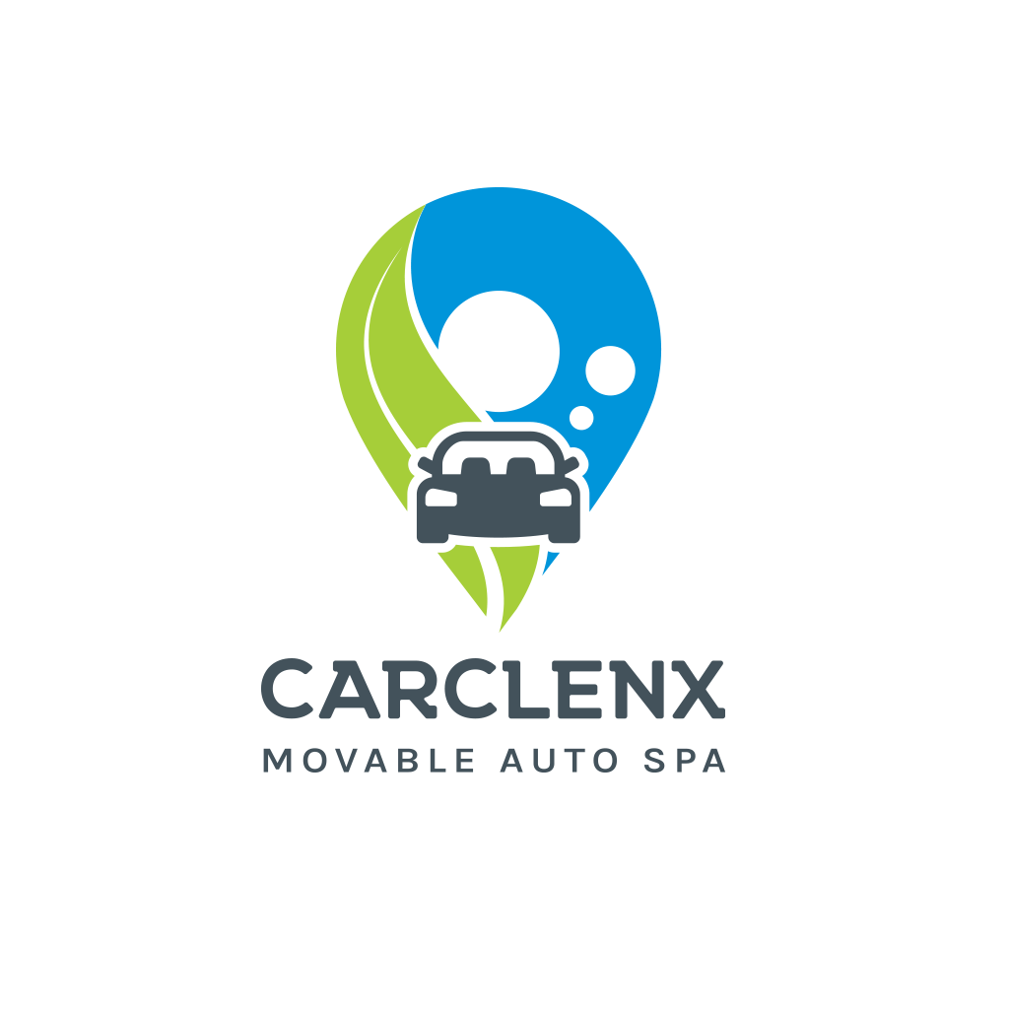

You Can Refer From Carclenx Official Medias.

Fb Link : <https://www.facebook.com/carclenx/>

Website : <https://carclenx.com/>

*******Submit the dedicated creative design at the earliest*******